|  |
| --- |
| Team JDK |
| Software Design Description |
|  |

|  |
| --- |
| Kotah Chapman, Jacob Jones, Donnie Sandlin  10/31/2017 |

Software design description

Part 1: data design

I) Notification System-

The notification will be a database of events and will use a sound or vibrate to alert the user of the alarm. Google calendar will be used for this, since the client is already using and it will be easy in integrate into the notification system. Users will have the option of editing the data that is contained in the calendar from the app. Functions will include the usual features like; add, delete, edit, etc. A view controller will be used to allow the manipulation of data inside of the app.

II) Weather

This will display the data all on one page and everything will be pulled from an API. Data that will be displayed on the weather is frost, temperature, rain, and other related weather things. We are also going to have a feature so the user can search any location using Google Maps.

III) Inventory

Inventory will be a scalable database and will consist of multiple tables. Each table will have its own separate view for the user to see the data. Users will also have the ability to edit the data in the table, which will update the database. A couple of table examples will include animals and inventory so they can stay separated from each other. Each of the tables in the database will be formatted for readability.

Part 2: 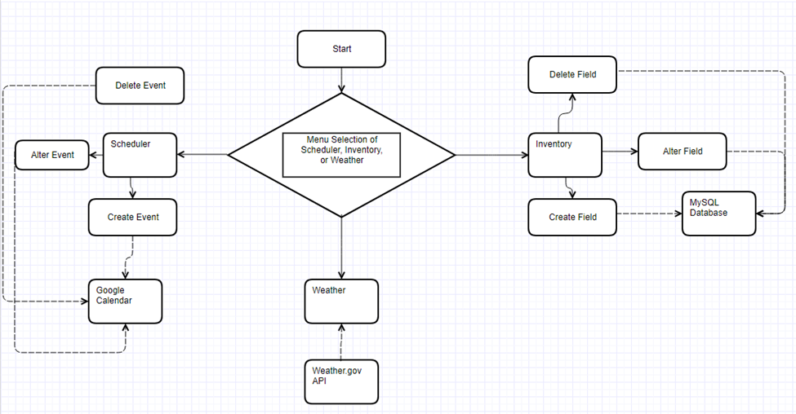

Part 3:

General UI design features: Each screen of the application will have a couple features always present. At the bottom, there will be buttons to immediately access any of the three major functions. Whichever the user is currently on will be highlighted. At the top of the screen, text will be displayed to inform the user on exactly which screen they are on. Located at the top right will be a drop down menu for various options.

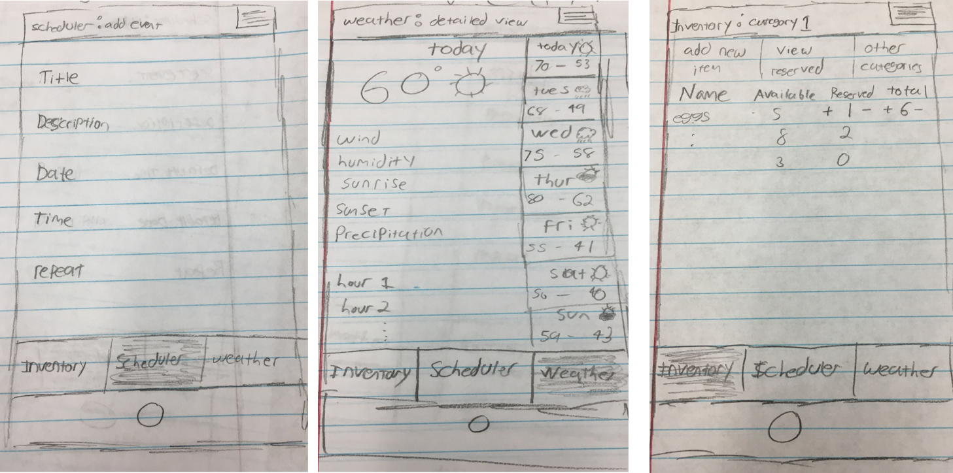

Scheduler Screen: Will have two display screens. One of which will display the users google calendar in app. The other screen will allow the user to create and edit events using a variety of dropdown boxes and text boxes.

Weather Screen: The weather screen will automatically display the day’s weather when selected. It will contain all the user requested info. Additionally it will contain the week’s weather on the right side of the screen. If any of the days are selected, its data will be displayed on the primary screen.

Inventory Screen: The inventory screen will display all the data from whatever table is selected. From this screen the user will be able to edit various entries in the table. There will be a secondary screen for adding new items to any table.

Part 4: 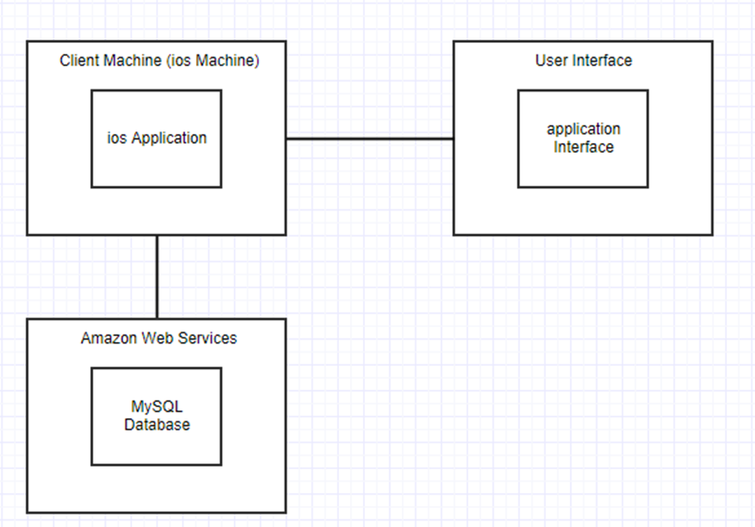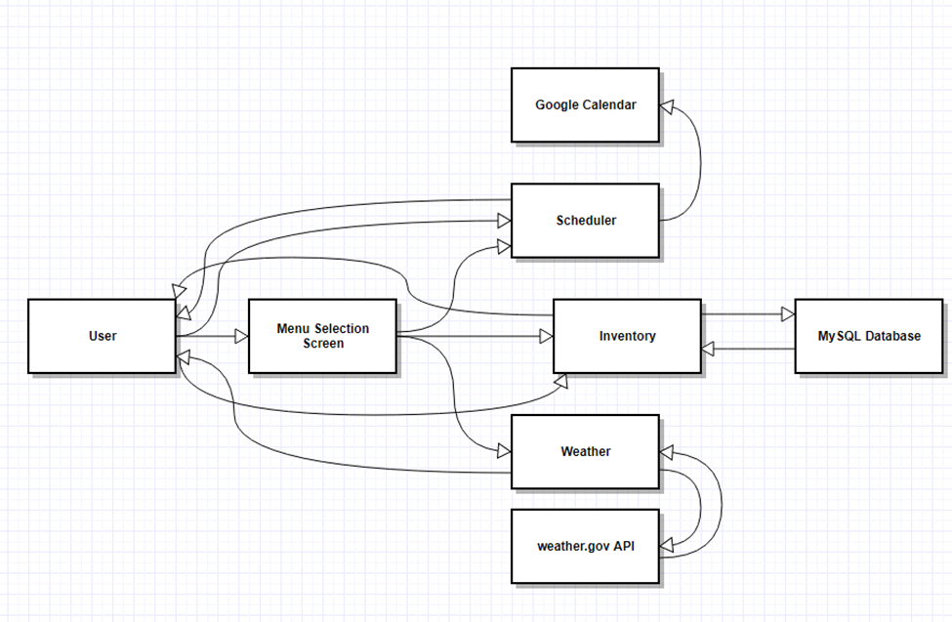

Contributions –

Donnie – Lead Documentation

Kotah – Lead Programmer

Jacob – Team Lead